### Exploring the Restaurant scenario in the Neighbourhood of Jaipur

**Applied Data Science capstone project for IBM/Coursera**

* Table of Contents
* Introduction
* Data Collection from APIs
* Data Cleaning
* Methodology
* Analysis
* Results and Discussion
* Conclusion

**Introduction**

Jaipur is the capital and the largest city of the Indian state of Rajasthan. As of 2011, the city had a population of 3.1 million, making it the tenth most populous city in the country. Jaipur is also known as the Pink City, due to the dominant colour scheme of its buildings.] It is located 268 km (167 miles) from the national capital New Delhi. Jaipur is a popular tourist destination in India and forms a part of the west Golden Triangle tourist circuit along with Delhi and Agra (240 km, 149 mi). It also serves as a gateway to other tourist destinations in Rajasthan such as Jodhpur (348 km, 216 mi), Jaisalmer (571 km, 355 mi), Udaipur (421 km, 262 mi), Kota (252 km, 156 mi) and Mount Abu (520 km, 323 mi). Jaipur is located 616km from Shimla.

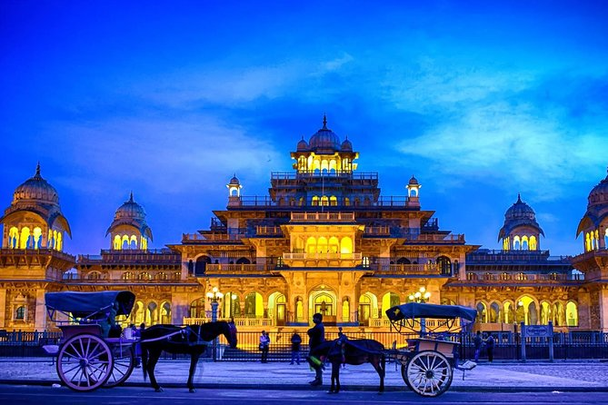

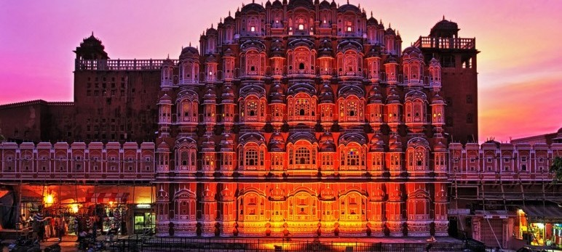

The aim of the project is to identify venues in Jaipur, India based on their rating and average prices. In this notebook, we will identify various venues in the city of Jaipur, India, using Foursquare API and Zomato API, to help visitors select the restaurants that suit them the best.

Whenever a user is visiting a city they start looking for places to visit during their stay. They primarily look for places based on the venue ratings across all venues and the average prices such that the locations fits in their budget.

Here, we'll identify places that are fit for various individuals based on the information collected from the two APIs and Data Science. Once we have the plot with the venues, any company can launch an application using the same data and suggest users such information.

**Target Audience**

The target audience for such a project is twofold. Firstly, any person who is visiting Jaipur, The Pink City of Rajasthan. India can use the plots and maps from this project to quickly select places that suit their budget and rating preferences. Secondly, an entrepreneur who want to open new restaurants in Jaipur can use this information to create a website or a mobile application, which is updated on a regular basis, to allow individuals to the city or even expand same functionality to other places. We will use the data science tools and techniques to understand or weigh in the pros and cons of a location. We provide an analysis for the stakeholders to take a data driven decision to choose the best category/location/price range in the city about most promising and viable option.

Jaipur is the capital and the largest city of the Indian state of Rajasthan. As of 2011, the city had a population of 3.1 million, making it the tenth most populous city in the country. Jaipur is also known as the Pink City, due to the dominant colour scheme of its buildings.] It is located 268 km (167 miles) from the national capital New Delhi.

**From Foursquare API (**[**https://api.foursquare.com/v2/venues/**](https://api.foursquare.com/v2/venues/)**) , retrieved the following for each venue:**

* Name: The name of the venue.
* Category: The category type as defined by the API.
* Latitude: The latitude value of the venue.
* Longitude: The longitude value of the venue.

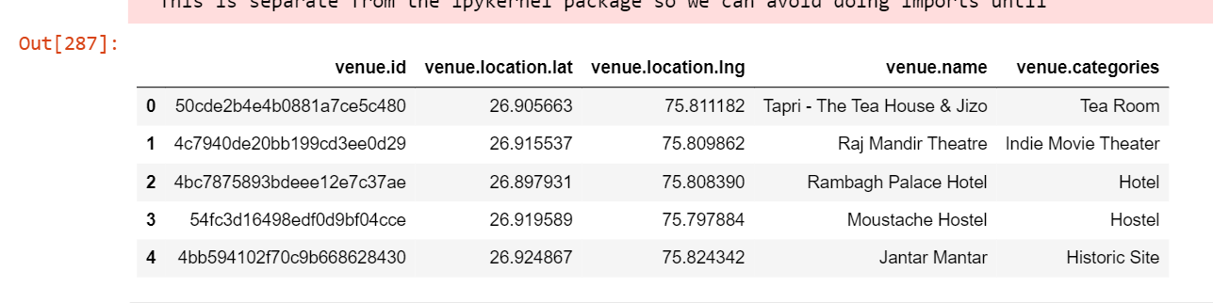

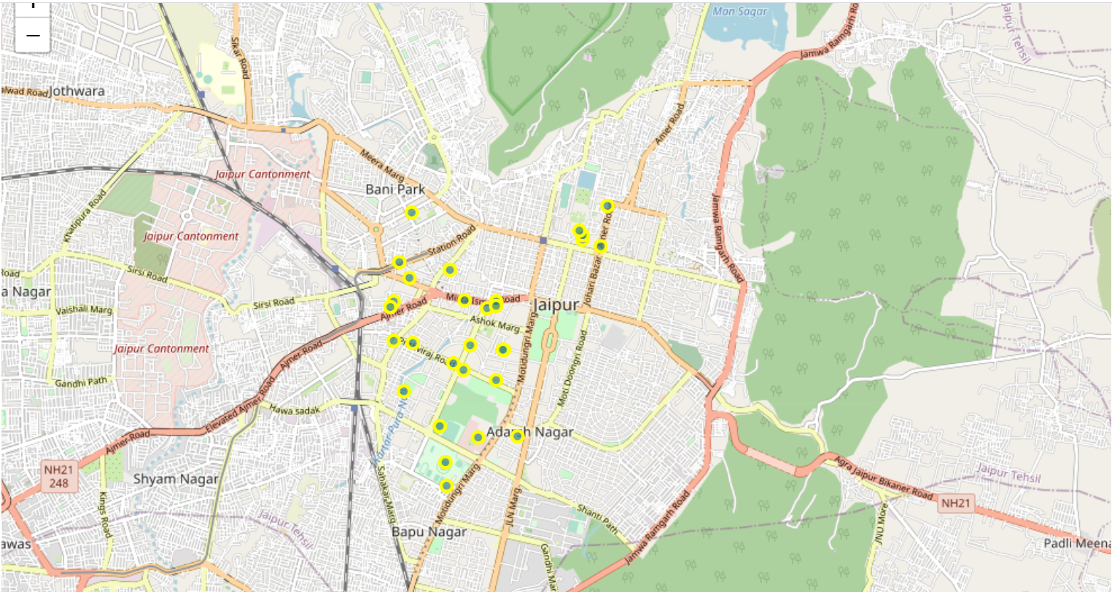

**From Zomato API (**[**https://developers.zomato.com/api**](https://developers.zomato.com/api)**), I retrieved the following for each venue:**

* Venue Name: The name of the venue.
* Address: The complete address of the venue.
* Rating: The ratings as provided by many users.
* Price range: The price range the venue belongs to as defined by Zomato.
* Price for two: The average cost for two people dining at the place.
* Latitude: The latitude value of the venue.
* Longitude: The longitude value of the venue.
* Cuisines: Cuisines of the venue

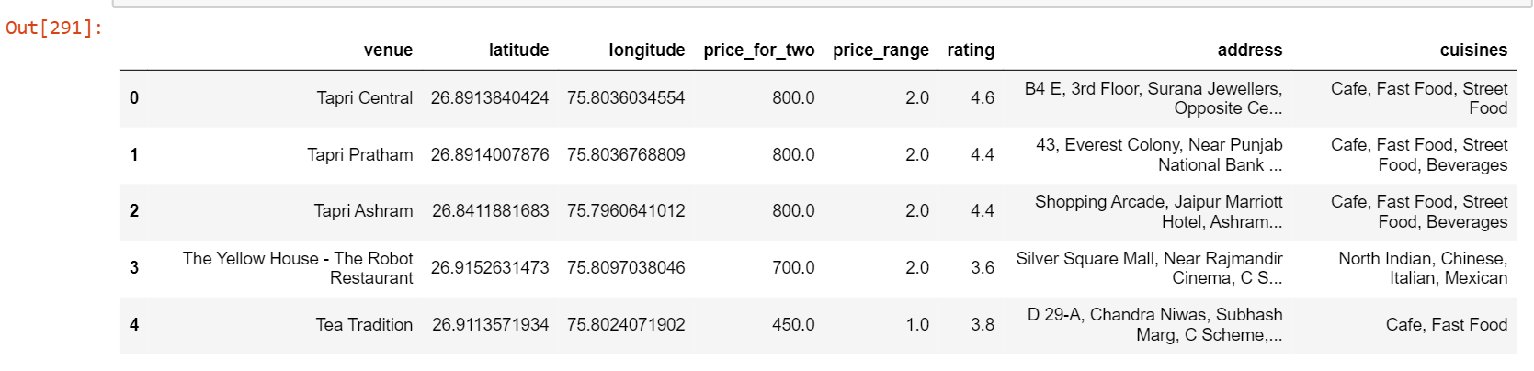

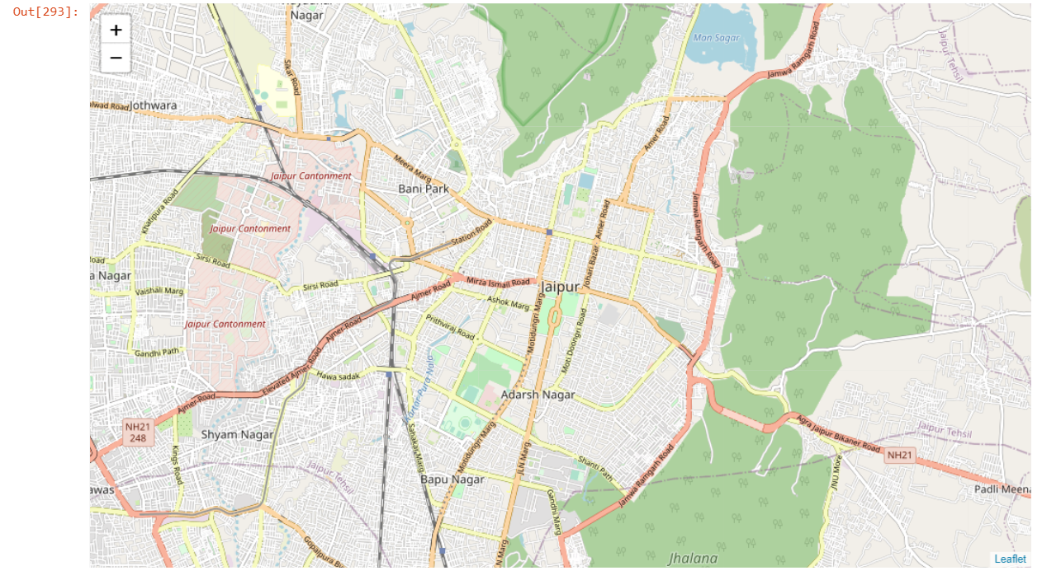

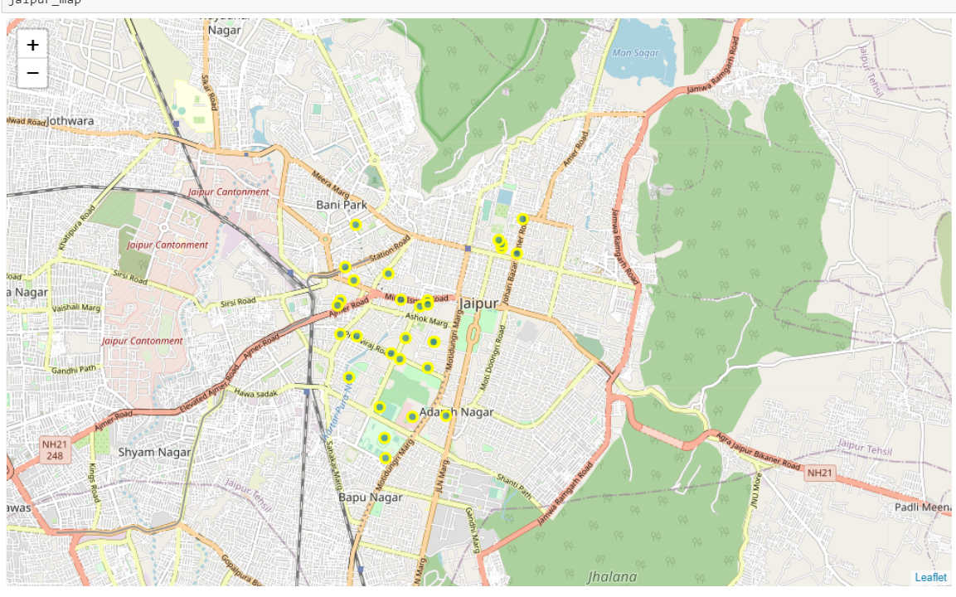

**Methodology**

In this project we will try to propose various profiles of restaurants around a defined central location, based on the ratings, price range and distance from the central location of the City. .We have selected a central location i.e NTR circle as the central location.

First we get all the locations from foursquare api, than get all the restaurants with user ratings, passing the venues of four square api as an input after that calculate distance from the defined central location to each of the restaurants, clustering based on ratings, distance,price range within 3 kms range from the central location for profiling the restaurants.

**Exploratory Data Analysis**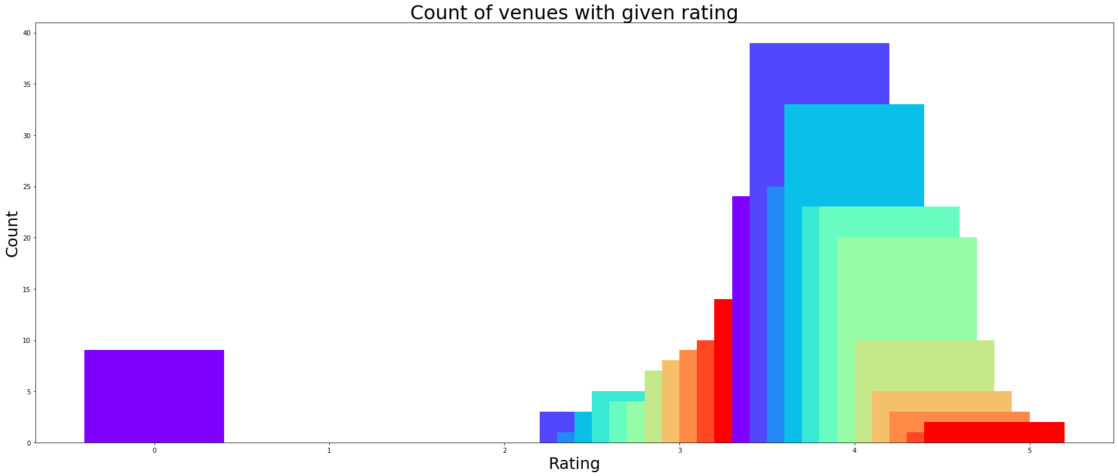

Rating

We will explore the data based on the rating.

From the above plots we can understand that the ratings of the restaurants are highly ranging from 2.5 to 5. About 20restaurants has the rating '0'.Lets explore the subset of the dataset which has poor rating of 0.

Rating as per Cuisines

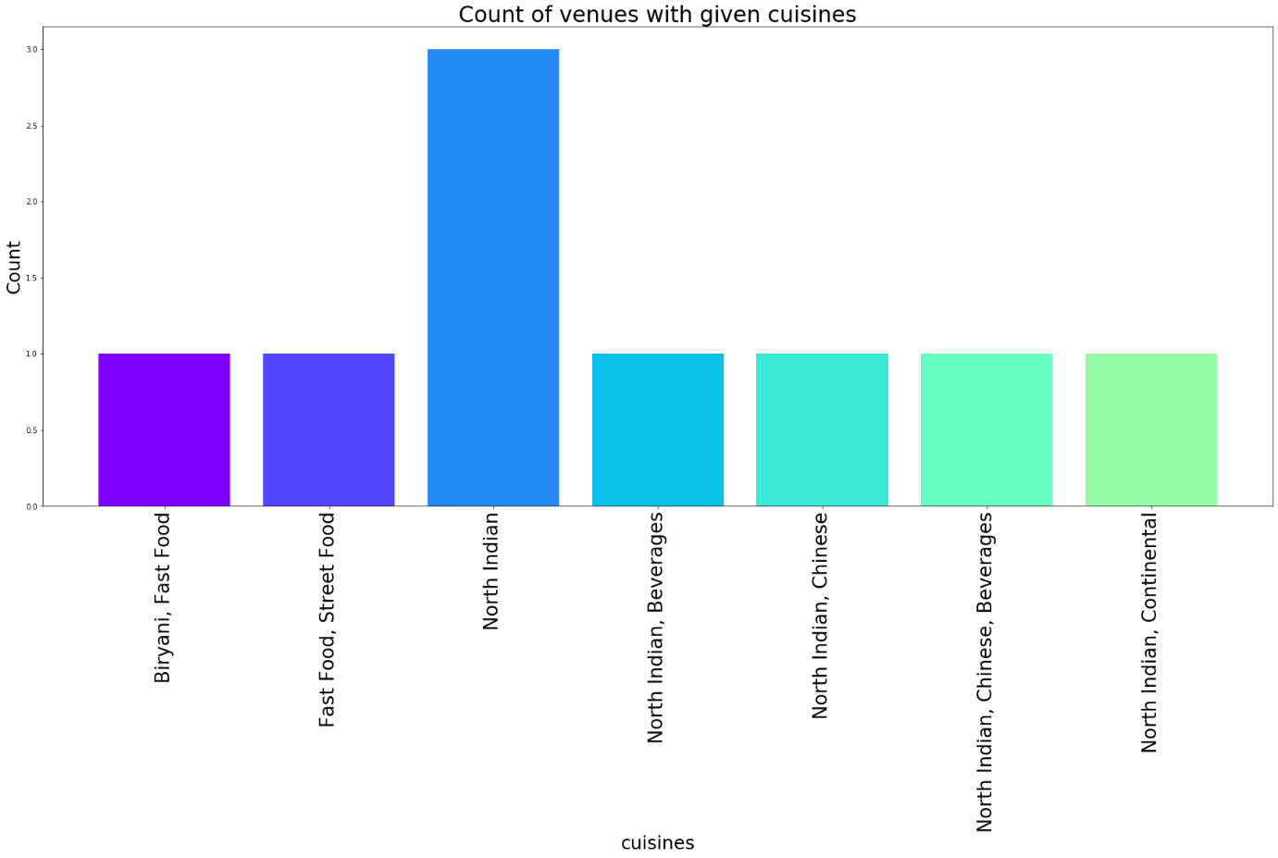

**Rating as per price range**

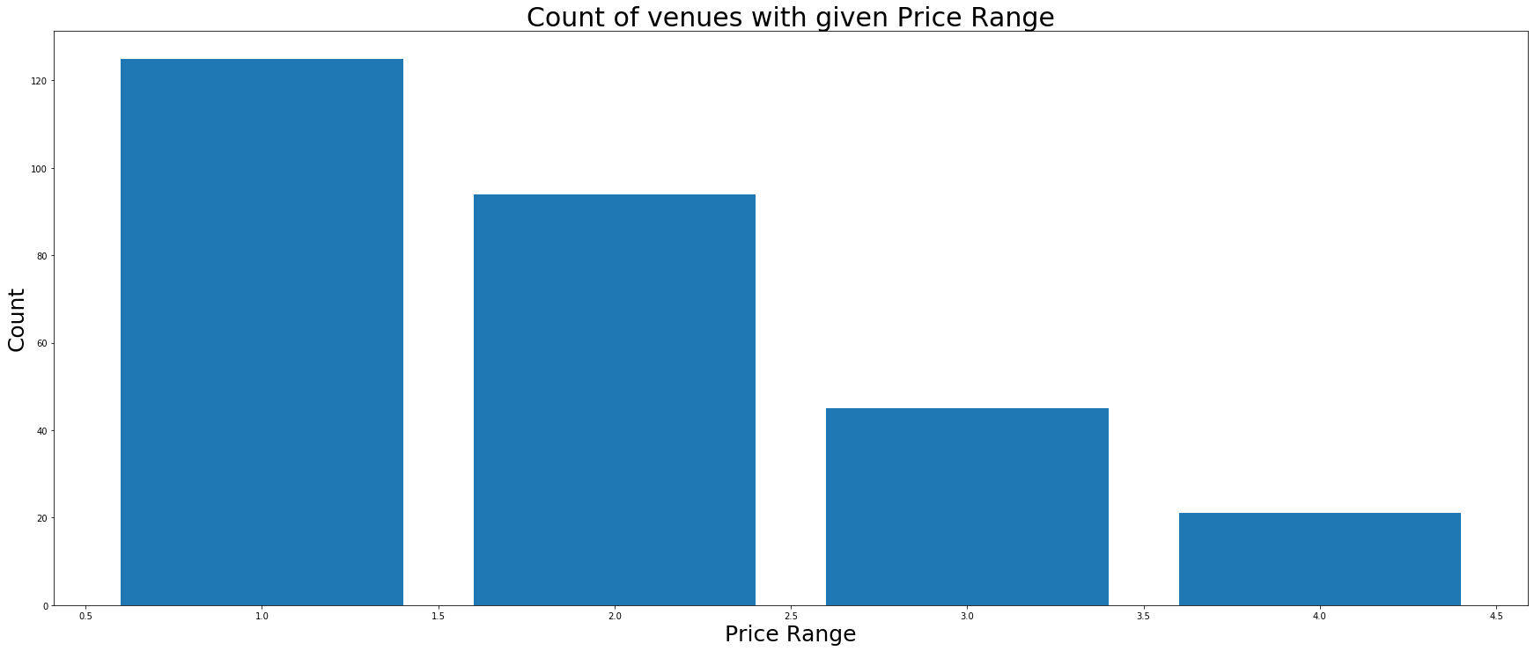

From the above plot we can understand that restaurants providing more or less same kind of cuisines have 0 rating. We can't assess which cuisine/category in particular has poor rating from the above plot.

price range for the distribution is pocket friendly in the city of Jaipur. Zomato Price_range explains cost range from 1 to 4(1 being the pocket friendly to 4 being expensive)

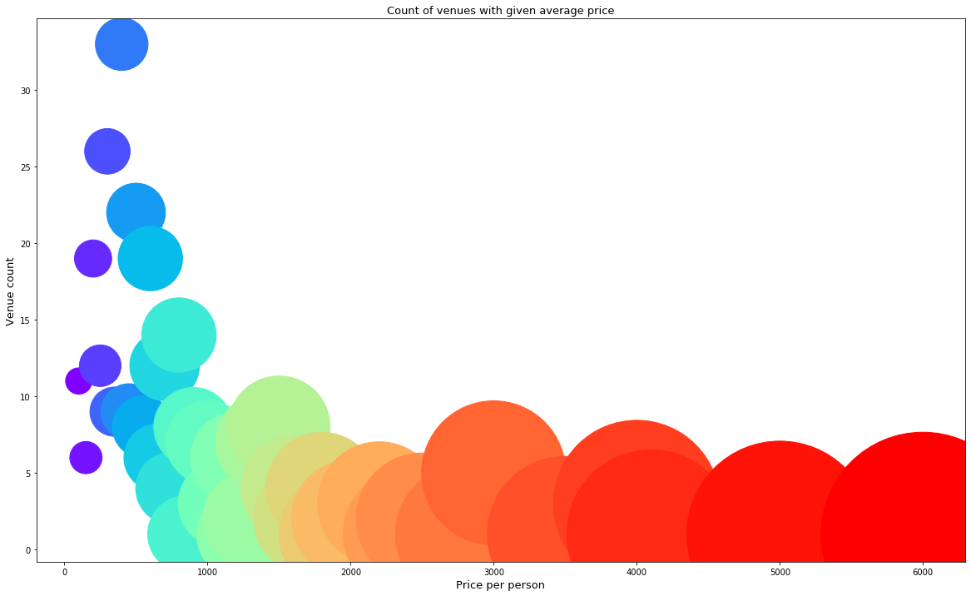

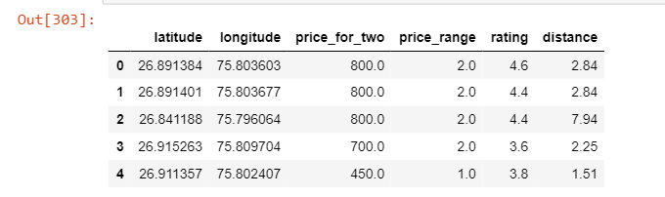

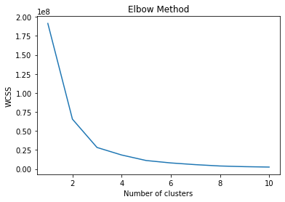

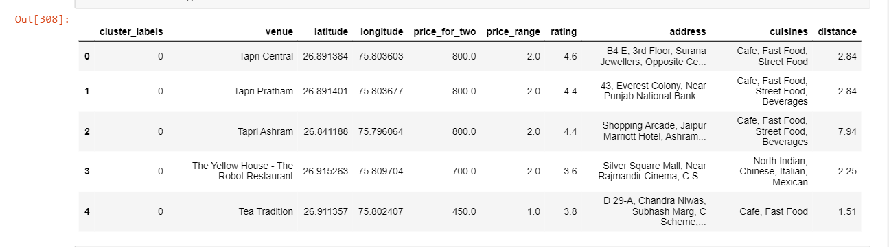

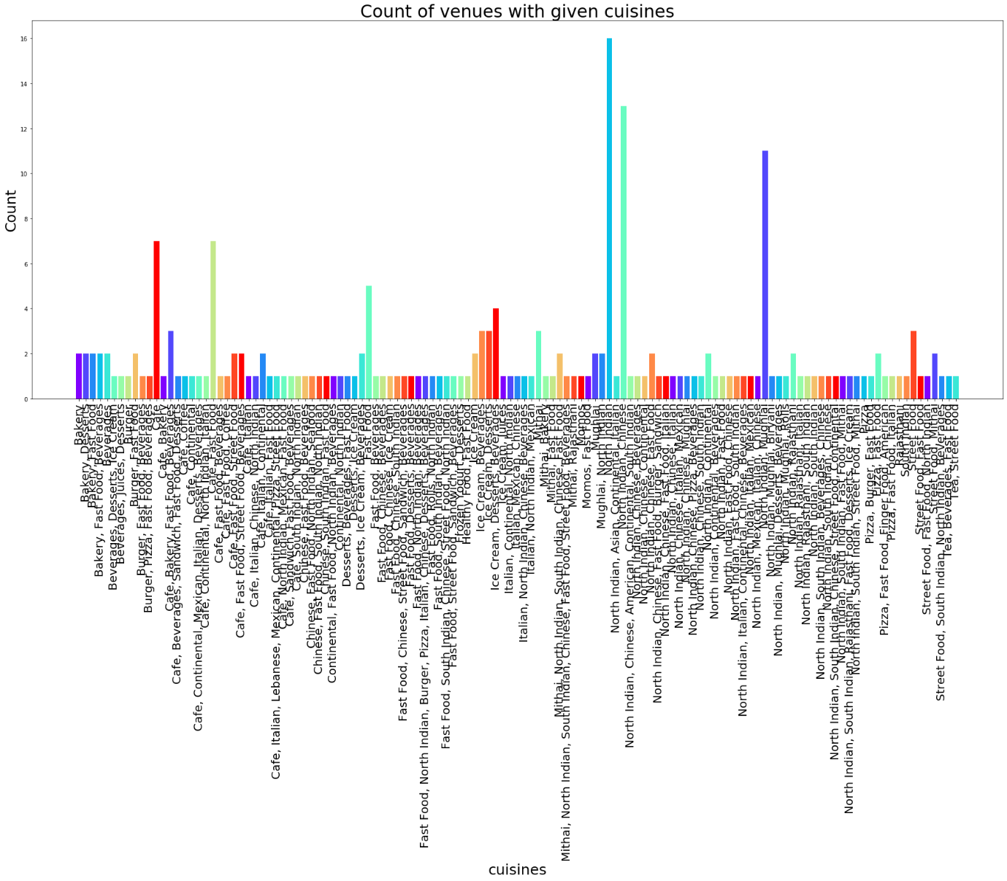

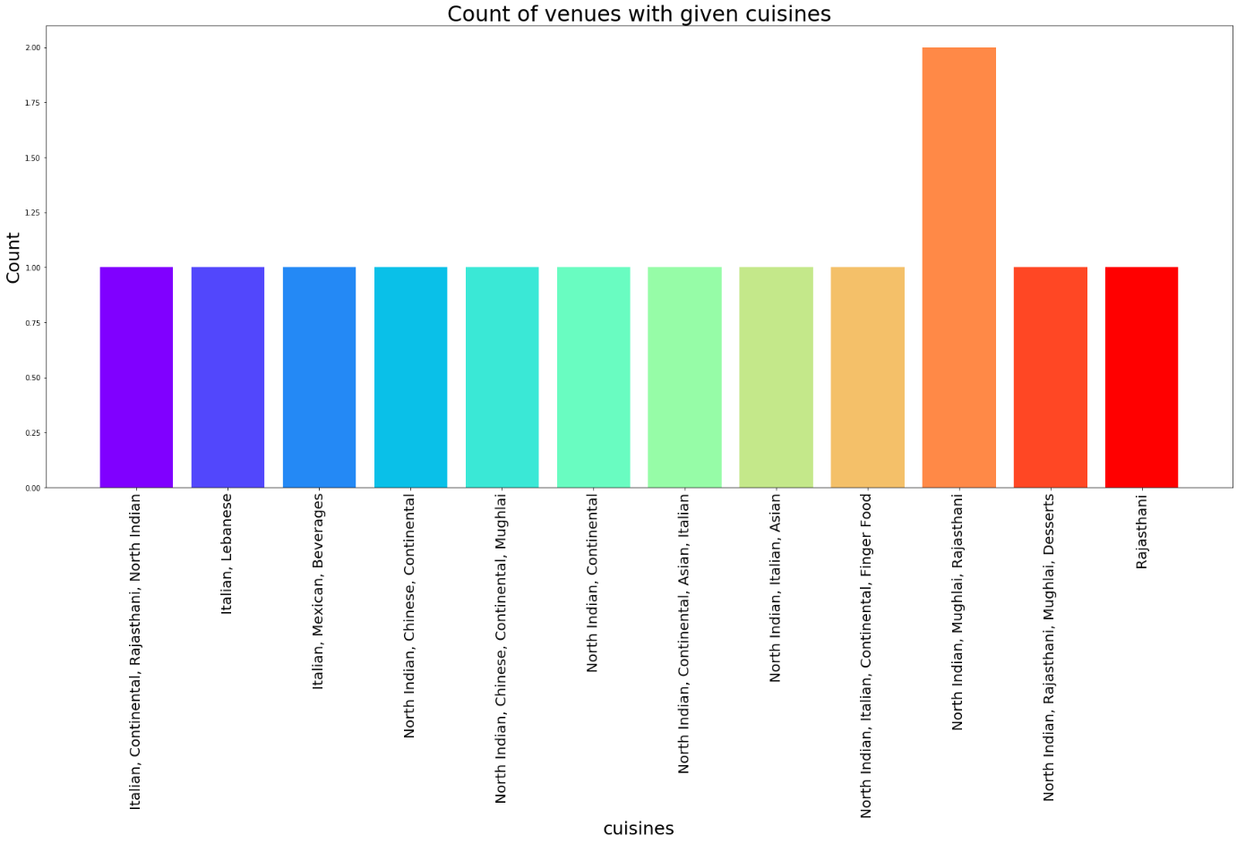

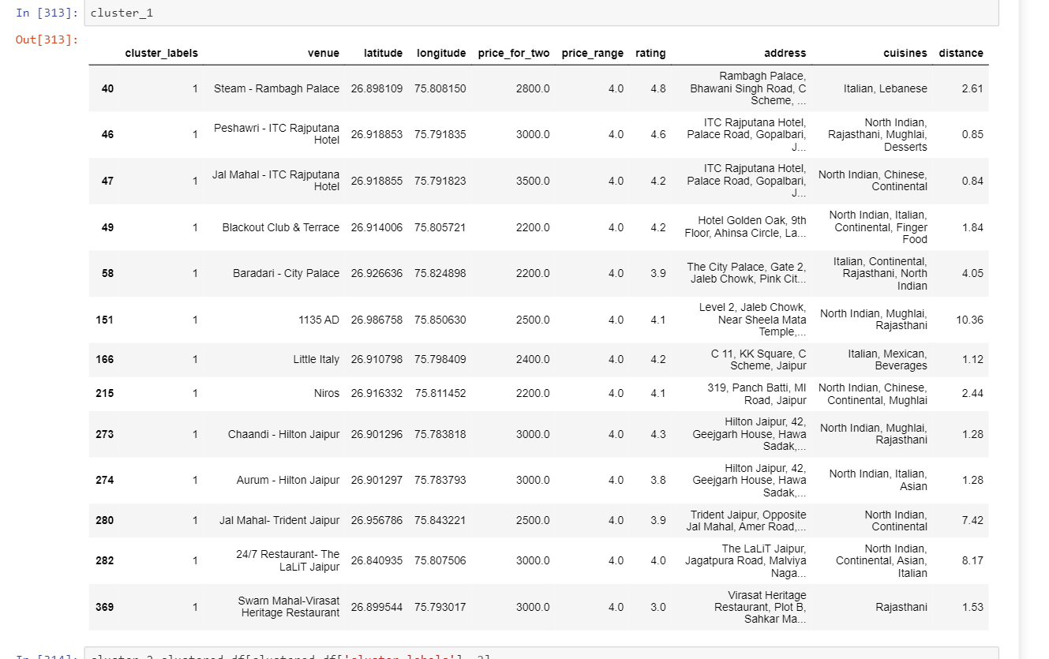

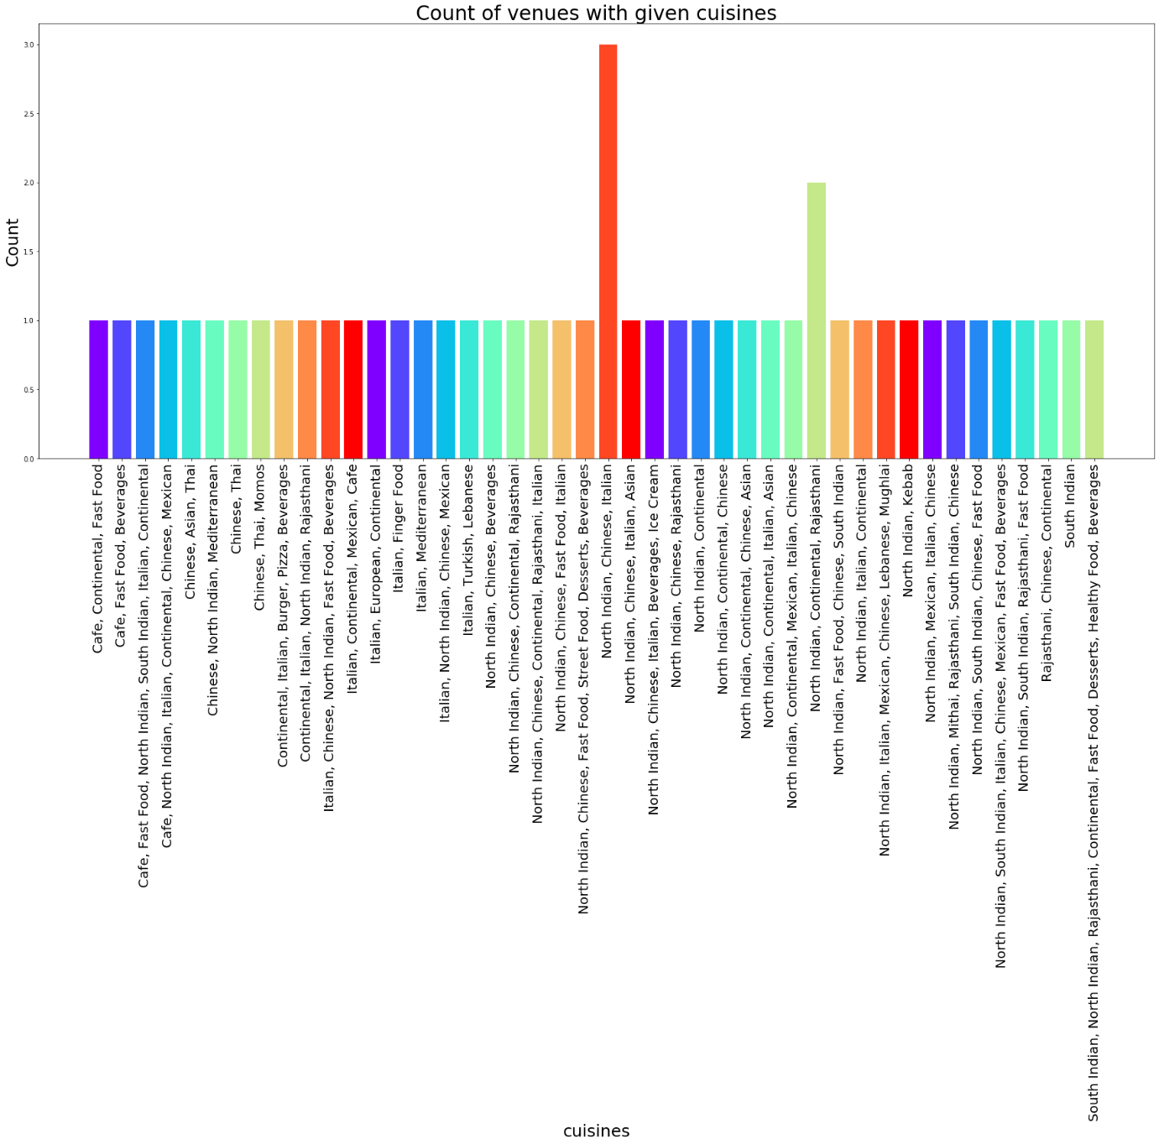

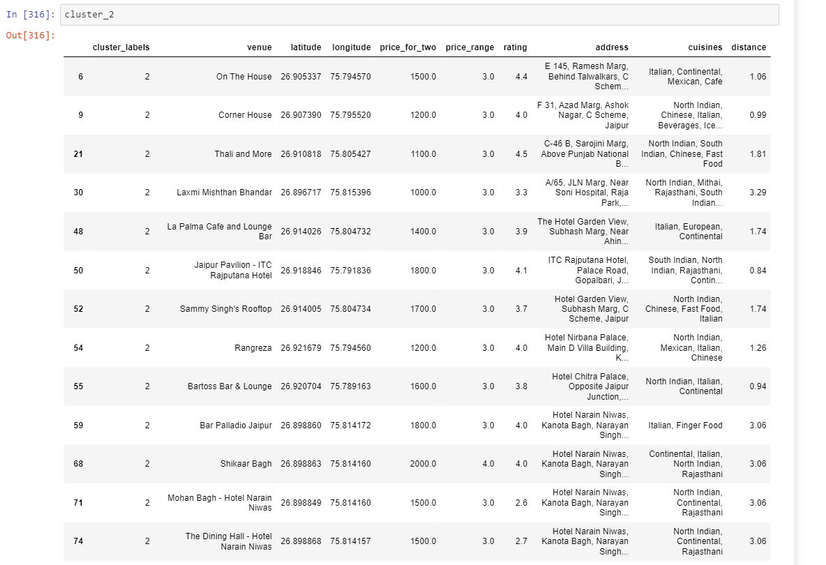

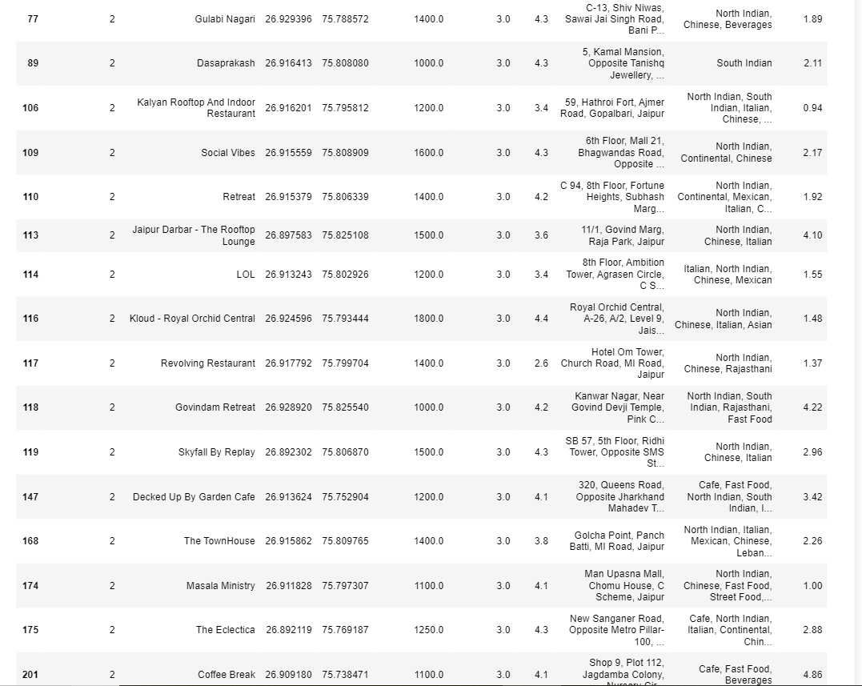

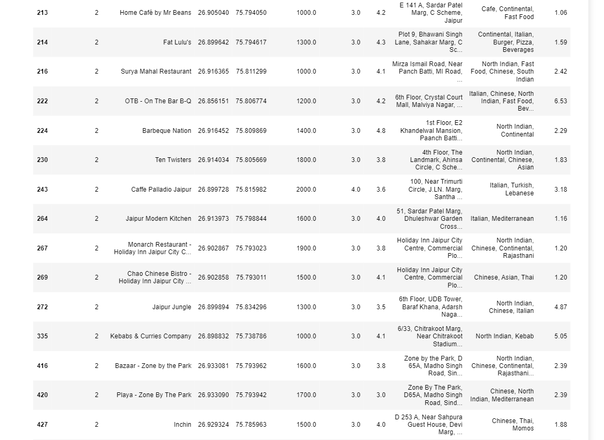

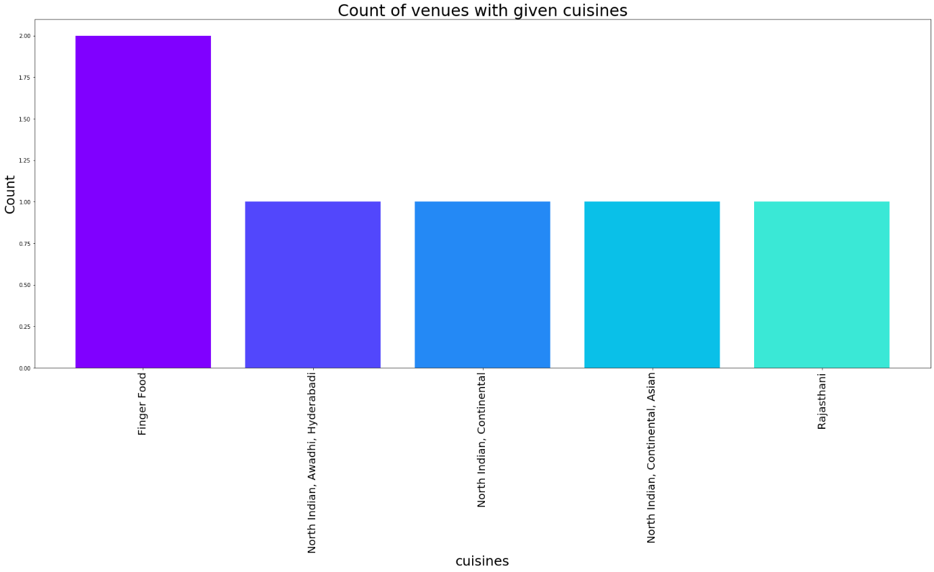

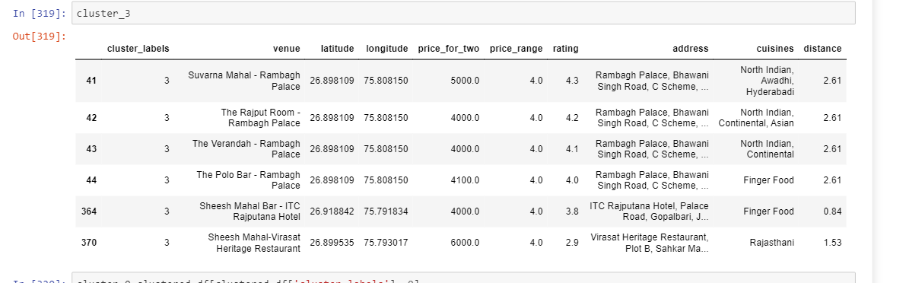

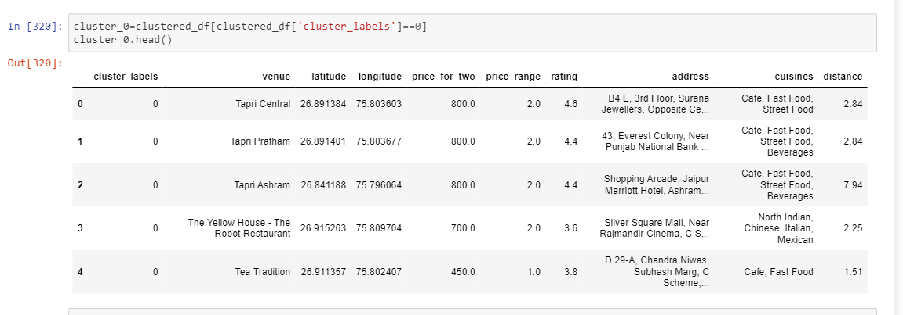

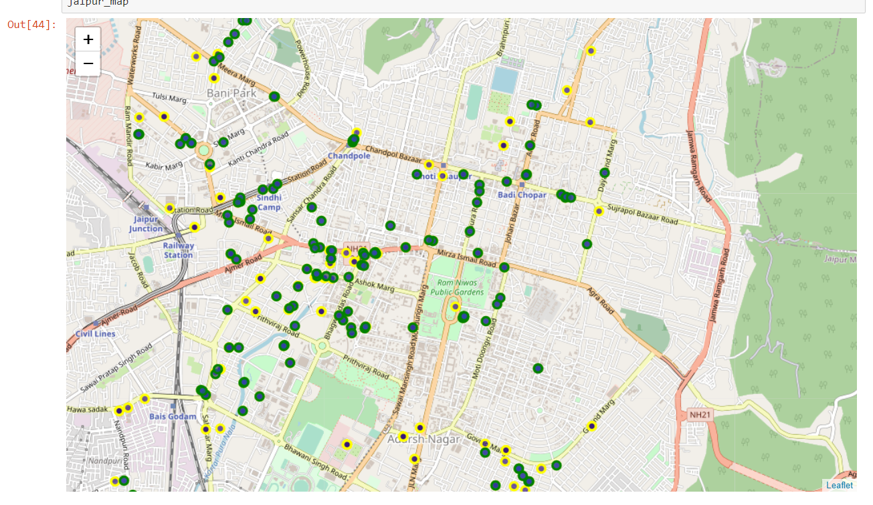

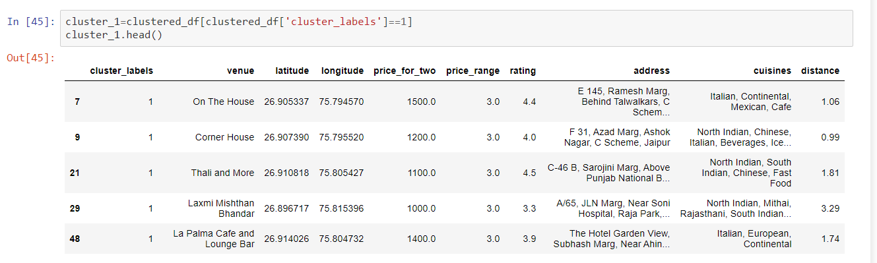

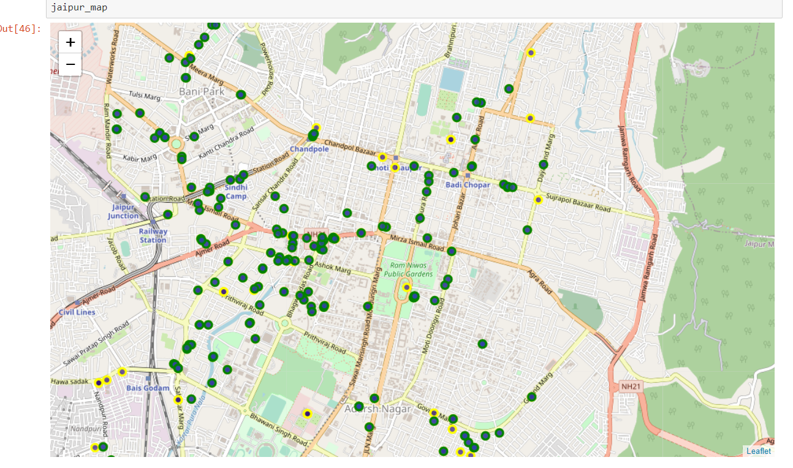

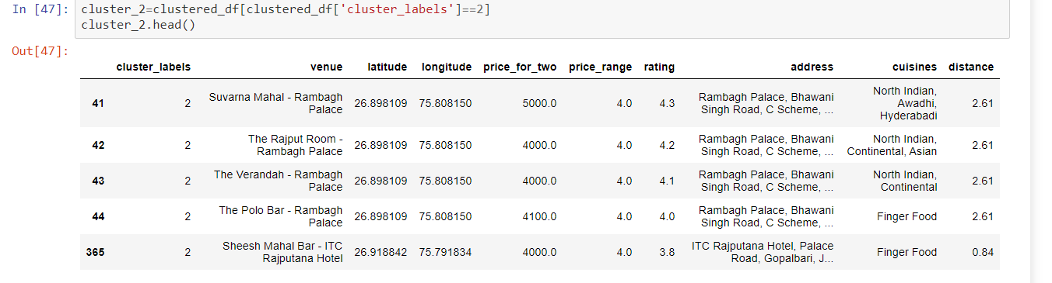

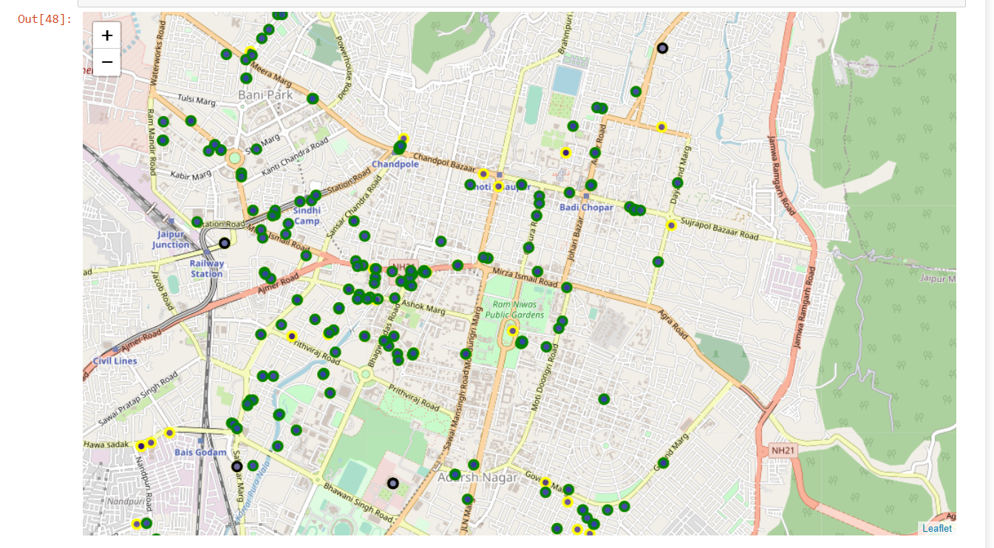

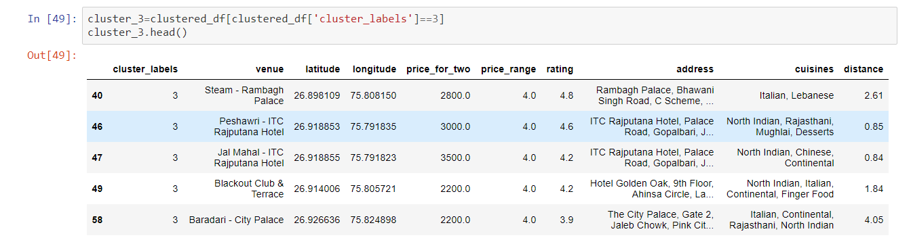

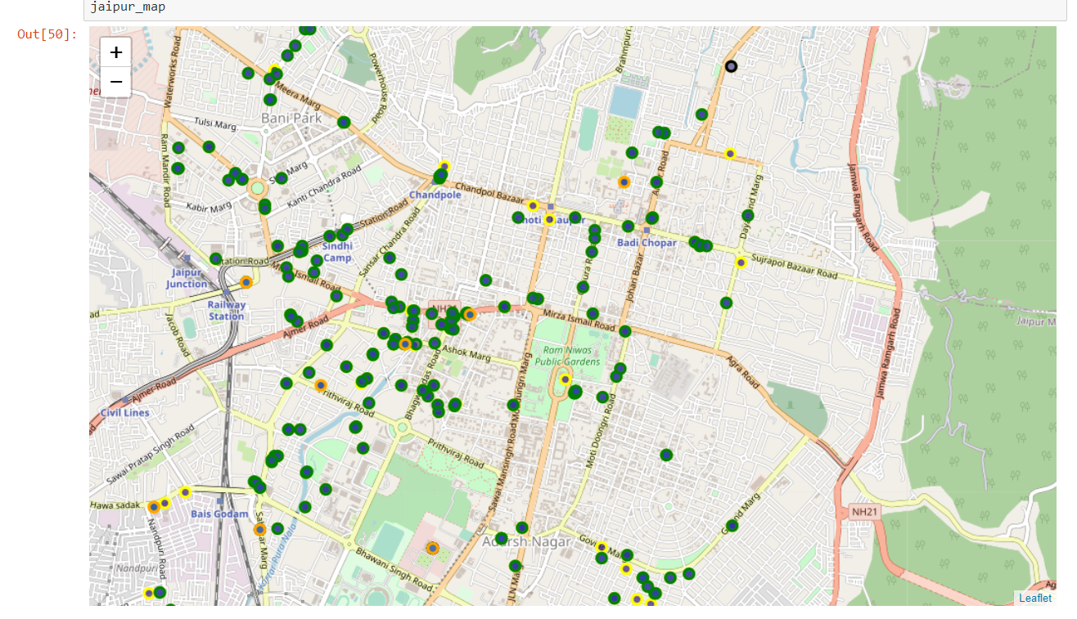

**Results and Discussion**

Based on the analysis we can draw many conclusions. We have profiled the clusters based on the price_ Range, rating, average price for two and distance from the centre.

**From cluster 0**

* Mean distance of a distance from central location of cluster 0: 3.723523809523808
* Mean rating of cluster 0: 3.8138095238095215
* Mean price rate for an individual of cluster 0: 227.26190476190476
* There are 210 restaurants in cluster 0
* 76.09 % of restaurants are in cluster 0

**From cluster 1,**

* Mean distance of a distance from central location of cluster 1: 3.368461538461539
* Mean rating of cluster 1: 4.084615384615383
* Mean price rate for an individual of cluster 1: 1357.6923076923076
* There are 13 restaurants in cluster 1
* 4.71 % of restaurants are in cluster 1

**From cluster 2,**

* Mean distance of a distance from central location of cluster 2: 2.4697872340425535
* Mean rating of cluster 2: 3.899999999999999
* Mean price rate for an individual of cluster 2: 702.6595744680851
* There are 47 restaurants in cluster 2
* 17.03 % of restaurants are in cluster 2

**From cluster 3,**

* Mean distance of a distance from central location of cluster 3 2.135
* Mean rating of cluster 3: 3.8833333333333333
* Mean price rate for an individual of cluster 3: 2258.3333333333335
* There are 6 restaurants in cluster
* 2.17 % of restaurants are in cluster 3

As per analysis, we can suggest that cluster 0 and cluster 2 is budgeted restaurants for medium class with rating ranging between 3 to 4, which can be considered for dinning for tourists and for any person want to visit restaurants in Jaipur. Cluster 1 is little expensive compare to cluster 0 and 2 with same rating coming as in cluster 0 and 2. Cluster 3 is very expensive with rating 3

On the basis of data analysis for restaurants in Jaipur. Anyone can use this information to build up an online website/mobile application, to provide users with up to date information about various venues in the city based on the search criteria (name, rating and price).

**Conclusion**

The purpose of this project was to explore the places that a person visiting Jaipur could visit. The venues have been identified using Foursquare and Zomato API and have been plotted on the map